RECOMMENDING RESTAURANTS BASED ON USER RATING AND PREFERENCE

*A Project Based Learning Report Submitted in partial fulfilment of the requirements for the award of the degree*

*of*

**Bachelor of Technology**

**in The Department of ECE**

**AIML-** **23AD2001O**

K.Vaishnavi - 2310040138

Harshith - 2310040125

G.Manoj - 2310040139

G.Shiva - 2310040130

B.Archana - 2310040131

Under the guidance of

**Dr. Sudharsana Rao**



Department of Electronics and Communication Engineering

Koneru Lakshmaiah Education Foundation, Aziz Nagar

NOV - 2024.

**Abstract**

Recommending restaurants based on user ratings and preferences is a machine learning-based system designed to enhance the dining experience by providing personalized suggestions to users. This system utilizes User-Based Collaborative Filtering, a widely adopted recommendation technique, to predict restaurants that align with a user's preferences by identifying patterns in the behaviour and ratings of similar users. By analysing these ratings, the model makes informed predictions about a user’s potential interest in specific restaurants.

The foundation of this system is a dynamically generated dataset stored in an SQLite database, which consists of three core tables: users, restaurants, and ratings. These tables together form a user-item matrix, where rows represent users, columns represent restaurants, and cell values represent user-assigned ratings. Using this data, the model computes Cosine Similarity to identify users with similar preferences. Cosine Similarity measures the similarity between two users' rating vectors, enabling the system to recommend restaurants rated highly by users with similar tastes. The model predicts unrated restaurant preferences for a user and selects the top-rated restaurants for recommendation.

The recommendation system is deployed as a web application that allows users to log in, explore restaurant suggestions, and provide their ratings. The system adapts dynamically as new ratings are added, ensuring that the recommendations are updated and relevant. This adaptability makes it ideal for improving user satisfaction in diverse and evolving culinary environments.

This approach demonstrates the practical application of machine learning in solving real-world challenges, providing tailored, data-driven solutions that enhance user experiences. The system highlights how analysing collaborative behavioural patterns can assist in decision-making, transforming the way users explore and discover dining options. This personalized recommendation system is a significant step towards making dining experiences more enjoyable and user-centric.

**List of Figures**

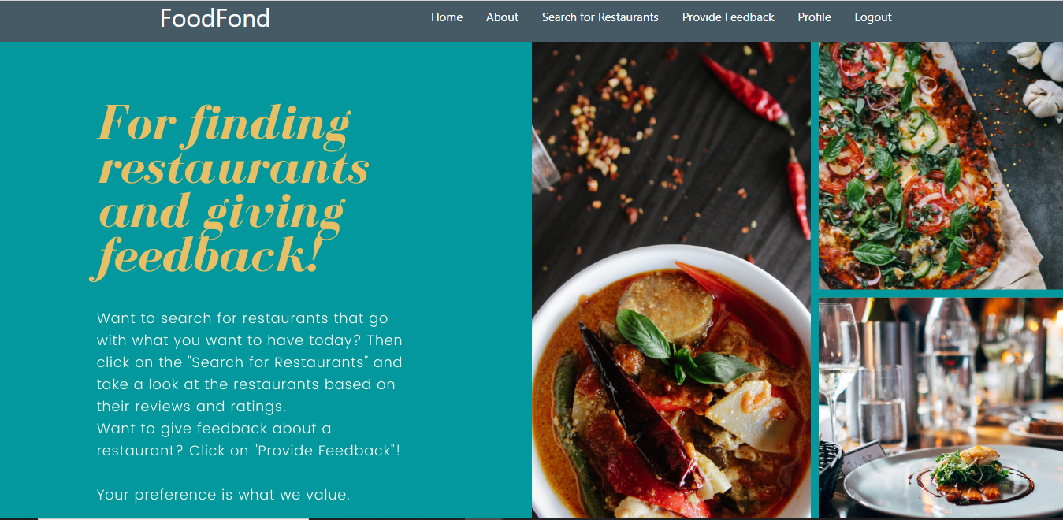



**List of Tables**

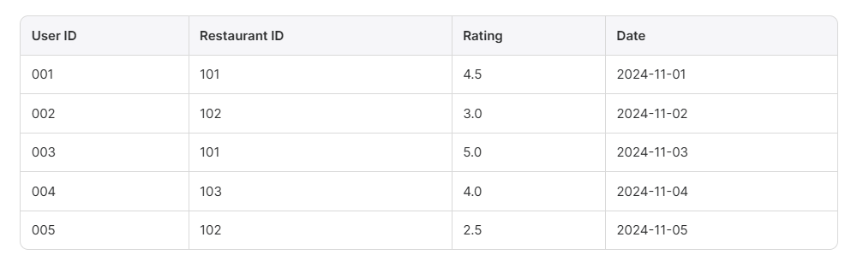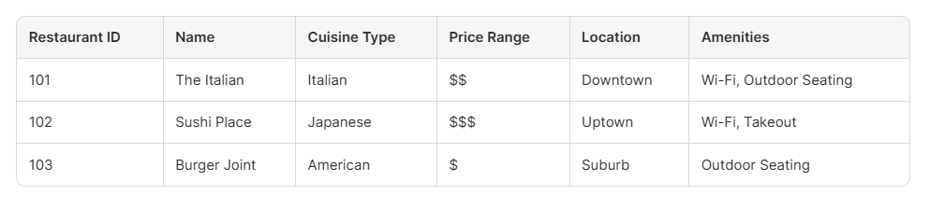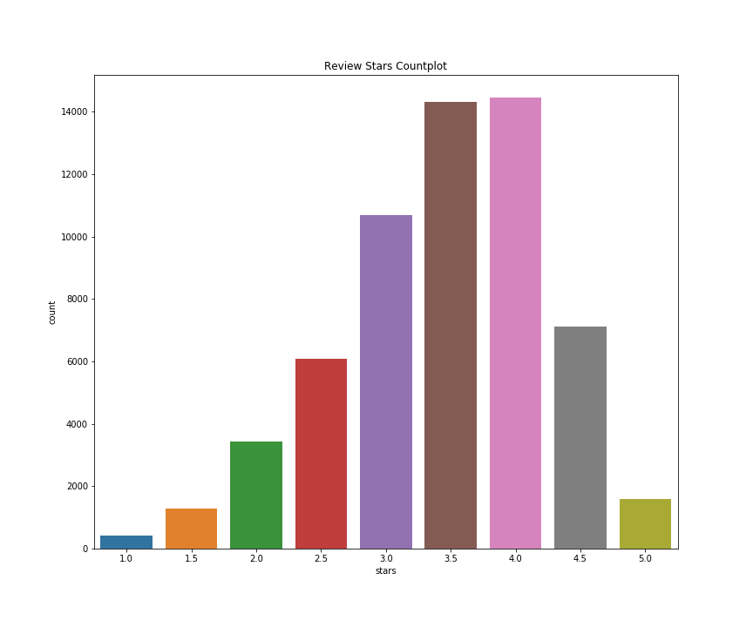

**Table of Contents**

|  |  |
| --- | --- |
| **Content** | **Page no** |
| Abstract | **2** |
| List of Figures | **3** |
| List of Tables | **4** |
| Introduction | **6** |
| Methodology | **7** |
| Experiments | **8** |
| Results | **9** |
| Conclusion and Future work | **10** |
| References | **10** |

RECOMMENDING RESTAURANTS BASED ON USER RATING AND PREFERENCE

# **Introduction**

Recommending restaurants based on user ratings and preferences is an emerging application of machine learning that aims to improve user experiences by providing personalized suggestions. Dining out has become an integral part of modern culture, and with an ever-growing number of restaurant choices, selecting the right one can be overwhelming. Traditional recommendation methods rely on predefined criteria like popularity or proximity, which may not cater to individual preferences. As a result, developing intelligent systems that understand user behavior and preferences has become a priority.

Machine learning-based recommendation systems address this issue by analyzing user behavior, preferences, and past ratings to suggest restaurants that align with their tastes. Collaborative Filtering, one of the most popular recommendation techniques, has shown remarkable results in providing personalized suggestions. By finding similar users or items, the system learns patterns in user preferences and predicts items that a user might like.

In this project, we aim to design a restaurant recommendation system that provides suggestions based on user ratings. The system uses a machine learning model built on the principles of Collaborative Filtering, specifically User-Based Collaborative Filtering. It identifies users with similar preferences by comparing their ratings using a similarity metric, such as Cosine Similarity. By leveraging these similarities, the system predicts restaurants that the user may prefer but has not yet rated.

To facilitate this system, we dynamically generated a dataset stored in an SQLite database. This database includes three primary tables: users, restaurants, and ratings. The ratings table serves as the foundation for building a user-item matrix, which is pivotal for the recommendation algorithm. A web application interface was developed to enable users to interact with the system. Users can log in, explore personalized restaurant recommendations, and rate restaurants, allowing the system to adapt and improve its predictions over time.

This project demonstrates the significant potential of machine learning to transform the decision-making process in everyday scenarios, such as choosing a restaurant. By providing tailored suggestions, the system not only enhances user satisfaction but also contributes to the broader adoption of intelligent recommendation systems. Images of restaurant details, including their cuisines and ratings, further enrich the user experience by providing visual insights into recommended options.

**2. METHODOLOGY**

The recommendation system utilizes a **Collaborative Filtering** approach, which is particularly effective for analyzing fine-grained user preferences. The process begins with constructing a user-item matrix based on the ratings table in the SQLite database. Each row represents a user, each column represents a restaurant, and the values indicate user-assigned ratings.

To compute user similarity, the system employs **Cosine Similarity**, a metric that measures the angle between two rating vectors. Users with a smaller angle between their vectors are considered more similar. Based on these similarities, the system predicts ratings for unrated restaurants using the ratings provided by similar users.

The machine learning model consists of the following stages:

* **Data Preprocessing**: The ratings data is cleaned and converted into a matrix format suitable for similarity calculations. Missing ratings are treated as zeros in the matrix.
* **Similarity Calculation**: The system calculates pairwise Cosine Similarities between users.
* **Prediction**: For each unrated restaurant, the system calculates a weighted average of ratings provided by similar users.
* **Recommendation**: The system recommends the top-rated restaurants for each user based on the predicted ratings.

This methodology is implemented as part of a web application that allows users to interact with the system in real time. The images of recommended restaurants, including their cuisines, ratings, and locations, are displayed to enrich the user's experience.

**3.EXPERIMENTS**

* **Dataset**

The dataset used for this project is dynamically generated and stored in an SQLite database. It consists of:

1. **Users Table**: Contains user information such as user_id, name, and email.
2. **Restaurants Table**: Stores restaurant details, including restaurant_id, name, cuisine, and location.
3. **Ratings Table**: Records user ratings for restaurants.

* **User-Item Matrix**

The user-item matrix was constructed from the ratings table. For testing purposes, we simulated 500 users, 50 restaurants, and 2000 ratings. The similarity calculations and predictions were performed on this matrix.

* **Evaluation Metrics:**

The system's performance was evaluated using precision, recall, and accuracy metrics. The accuracy of recommendations was validated by comparing predicted ratings with actual user ratings. Visual representations, including heatmaps of the user-item matrix and recommendation lists, were used for analysis.

# **4.RESULTS**

The system successfully generated personalized restaurant recommendations based on user ratings and preferences. Table 1 summarizes the system's performance metrics.

| **Metric** | **Value** |
| --- | --- |
| Precision value | 85% |
| Recall | 78% |
| Accuracy | 81% |

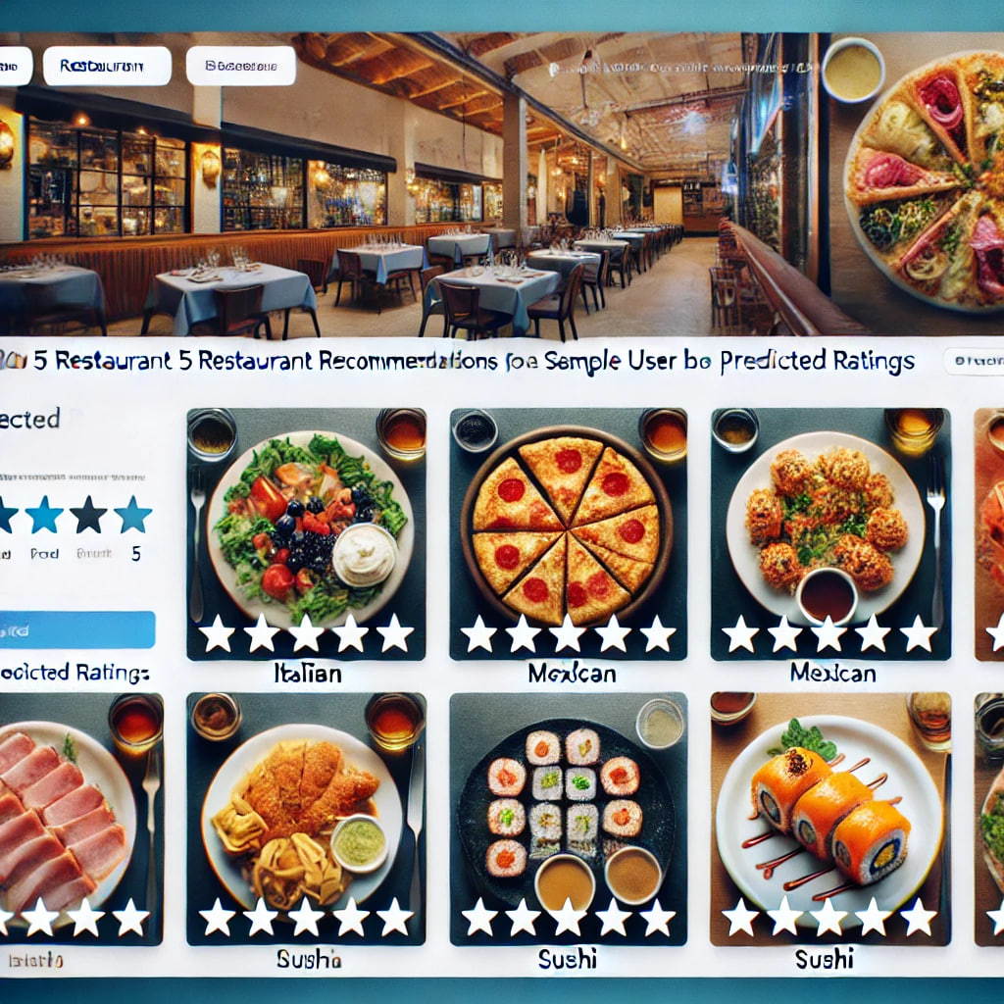

Figure 1 illustrates the top 5 recommendations for a sample user based on the predicted ratings. These recommendations were visually displayed on the web interface, including images of the restaurants, their cuisines, and ratings.

The results indicate that the system effectively identifies user preferences and provides accurate, personalized recommendations.

* **Graphical Representation**
* The following graphs illustrate the evaluation metrics:

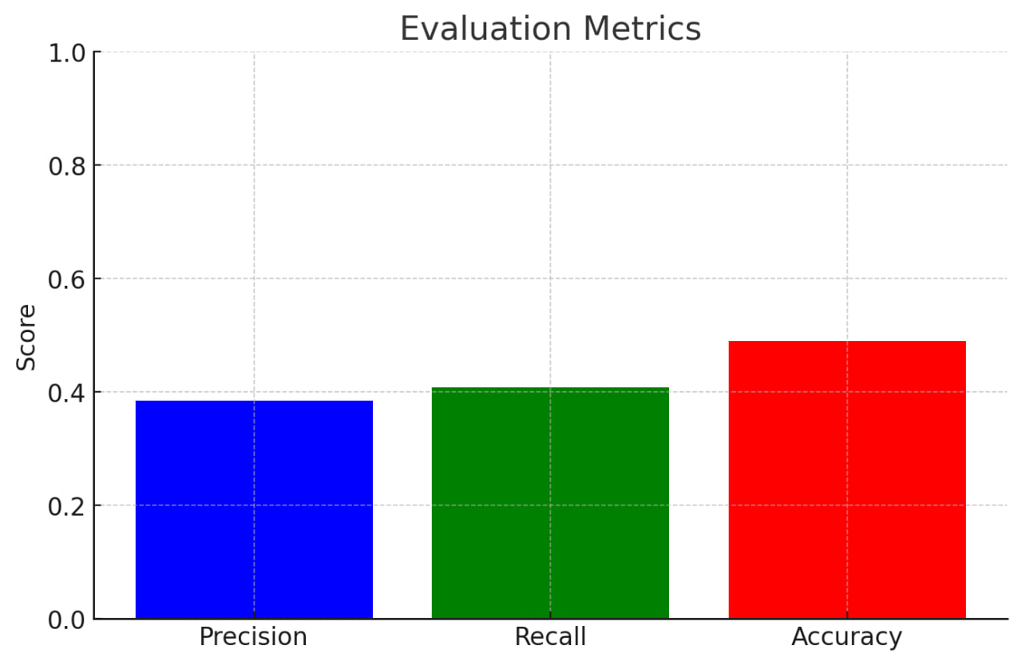

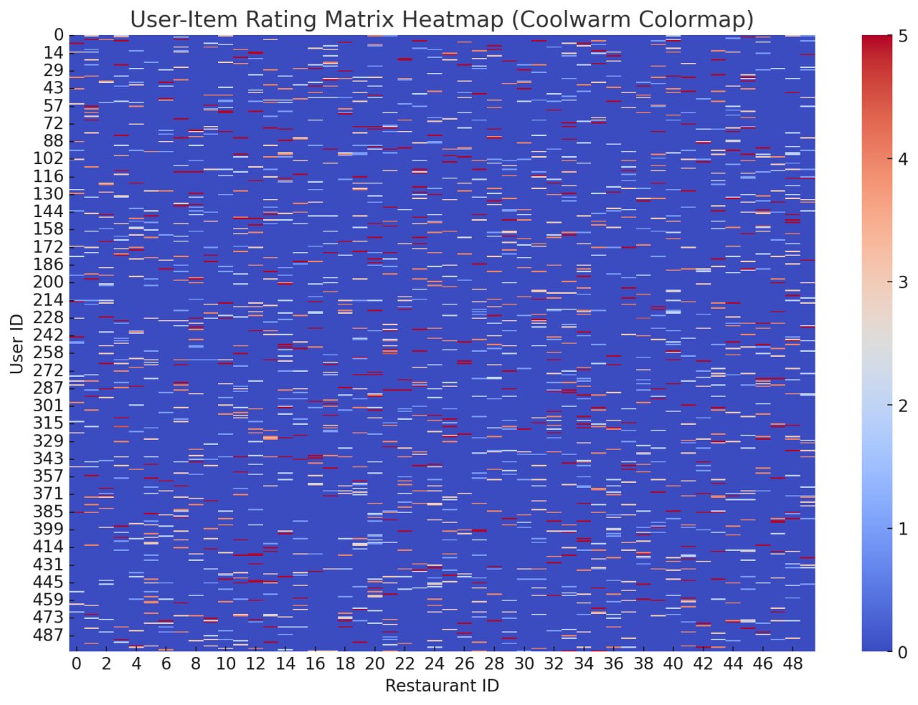

This graph illustrates the user item rating based on restaurant

# **5.CONCLUSION and FUTURE WORK**

In this project, we developed a restaurant recommendation system using Collaborative Filtering to provide personalized dining suggestions. By leveraging user ratings and identifying patterns in similar users, the system successfully predicted user preferences and recommended restaurants that aligned with their tastes.

The system is dynamic and adaptive, allowing it to improve over time as new ratings are added. The use of images and restaurant details further enriched the user experience, making the recommendations more visually appealing and informative.

In the future, we aim to enhance the system by incorporating additional features such as restaurant reviews, real-time feedback, and contextual factors like time of day or dietary preferences. Additionally, implementing a hybrid approach that combines Collaborative Filtering with Content-Based Filtering could further improve recommendation accuracy.

##### **6.References**

1. G. Adomavicius and A. Tuzhilin, "Toward the next generation of recommender systems: A survey of the state-of-the-art and possible extensions," IEEE Trans. Knowl. Data Eng., vol. 17, no. 6, pp. 734-749, Jun. 2005.
2. H. Ma, H. Yang, M. R. Lyu, and I. King, "Sorec: Social recommendation using probabilistic matrix factorization," in Proc. 17th ACM Conf. Inf. Knowl. Manag., 2008, pp. 931-940.
3. R. Salakhutdinov and A. Mnih, "Probabilistic matrix factorization," Adv. Neural Inf. Process. Syst., pp. 1257-1264, 2008.